**SMART PLANT MANAGEMENT SYSTEM**

**Introduction**

The Smart plant management system is an innovative system which will allow people to grow plants, vegetables and maintain gardens in a **hassle-free, seamless and effective manner**. The system will essentially grow the plants itself.

**Limitations in traditional and commonly used systems**

1. Sometimes people don’t have time to water plants during the weekdays, which generally results in the **plants dying**.
2. **Timer based watering systems in some cases lead to water wastage**. (E.g. - Overwatering, watering when it’s raining)
3. Different plants require **different amount of water**, which is not possible to implement in a regular watering system

**Our Solutions**  Instead of watering all plants at the same time everyday, the smart plant management system will use various sensors to measure **humidity, salinity, temperature, odour etc and will use weather forecasts**. This will ensure each plant gets how much water it needs and will reduce water wastage.

**How it works** The **trained system** will measure the **humidity, soil moisture and many other factors**, and will refer to our extensive database on each plant to decide when it needs to be watered. It will also **check the weather forecast** to determine whether the watering that day can be done naturally, hence **saving water**.

The system can be **controlled through an app** which will also provide all data and status updates on your phone.

**List of sensors**

1. Humidity sensor to check precipitation
2. Soil moisture sensor
3. pH sensor for soil
4. Odor sensor for CO2/O2
5. Temperature sensor

**Other Requirements**

1. Raspberry Pi
2. Arduino Microcontroller

**Methods of irrigation**

1. **Controlled** drip irrigation
2. Sprinkler irrigation system

**Implementation of sensors**

1. Humidity sensor: To check humidity/moisture content in the air
2. Soil moisture sensor: To check humidity/moisture content in the soil
3. pH sensor: To check pH level level of soil
4. Odor sensor for CO2/O2: To get a better idea of temperature near the plants as CO2 is a greenhouse gas. O2 detection will allow us to keep a check on the **rate of respiration of plants.**
5. CO2 level sensor: To check whether CO2/O2 levels are balanced and alert the user if **level of CO2 is too high** to remove a few plants. (Mostly will be used for plants indoors)
6. Temperature sensor: To check the temperature of the surroundings of plants.

**Soil moisture sensor:**

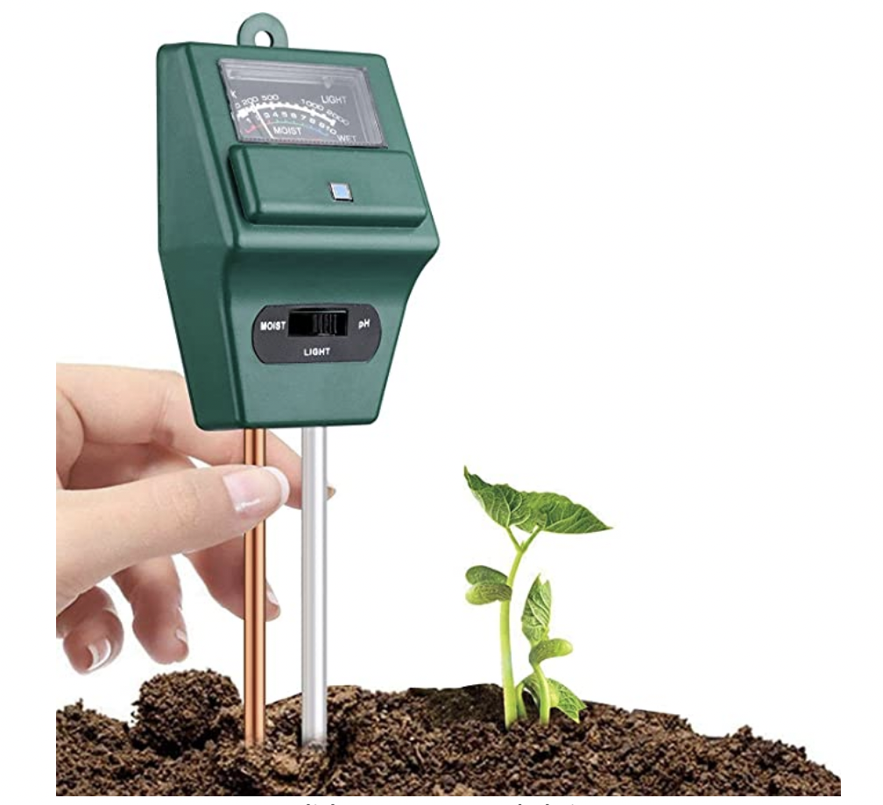

**Humidity sensor:**

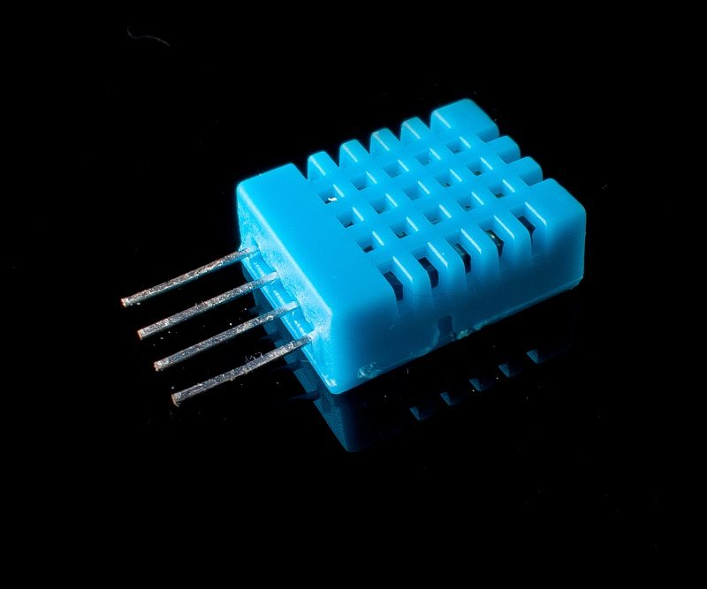

**pH sensor:**

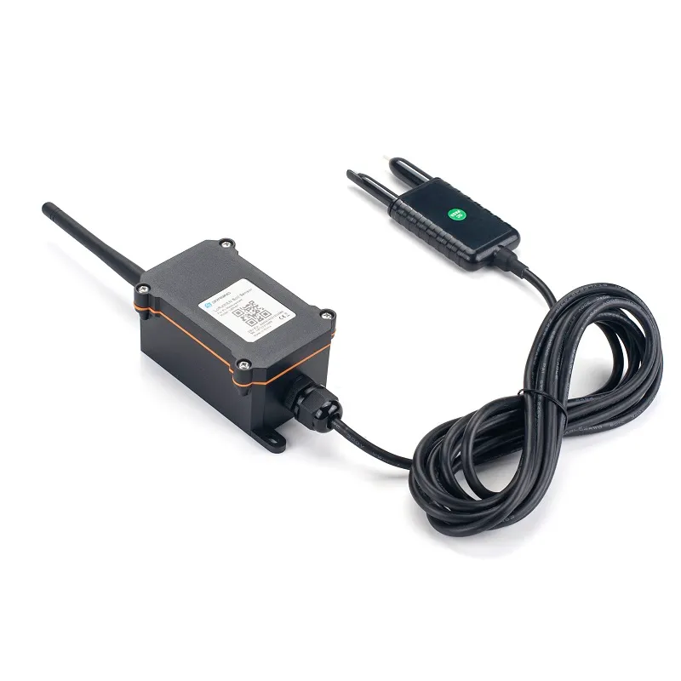

**CO2 sensor:**

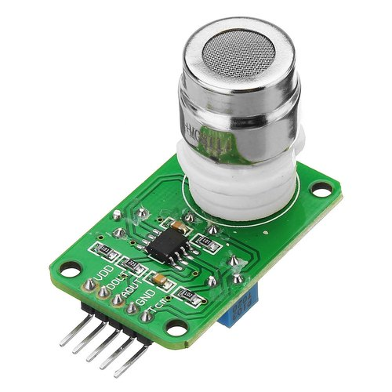

**Temperature Sensor:**

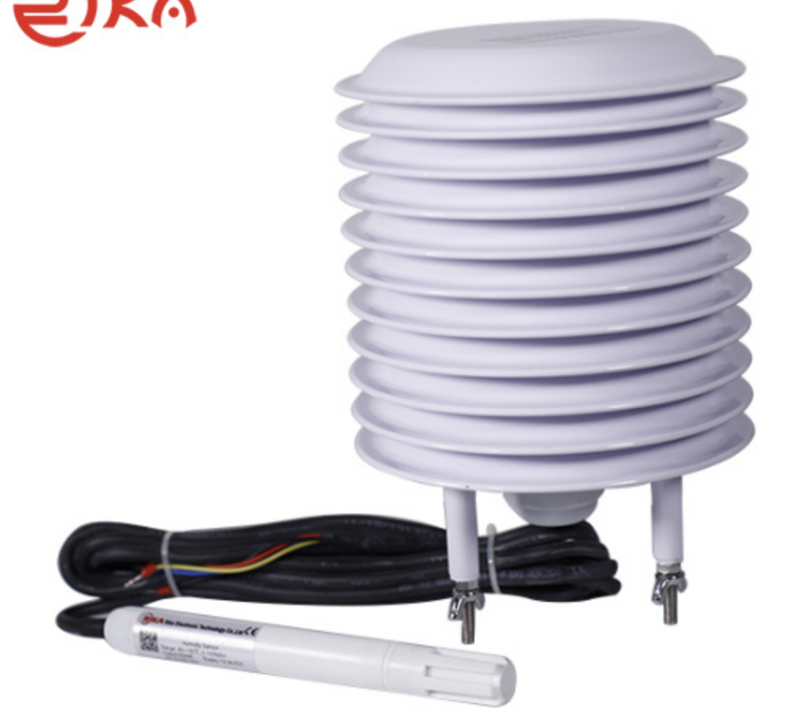

**Contd. On Next Page**

**Other Uses**

1. Outdoor lights can be controlled using CO2/O2 sensors as plants **give out Oxygen at daytime but Carbon Dioxide at night**, hence we can predict when it is getting dim outside and turn on the lights.
2. Family farms: Where you can **rent land** and **grow your own plants**, completely **automated** using the smart plant management system and **100% organic**. **YOU** decide how your food grows

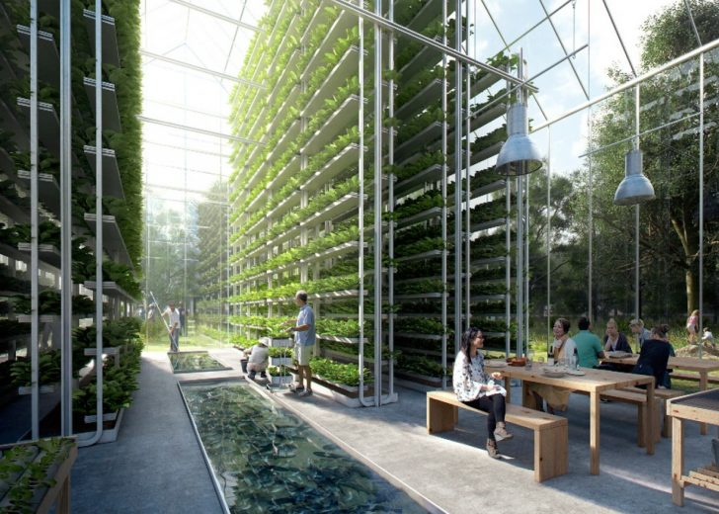

1. **Vertical gardening**: Since you don’t need to water the plants, vertical gardens become **more feasible.** **Less area, more efficient**

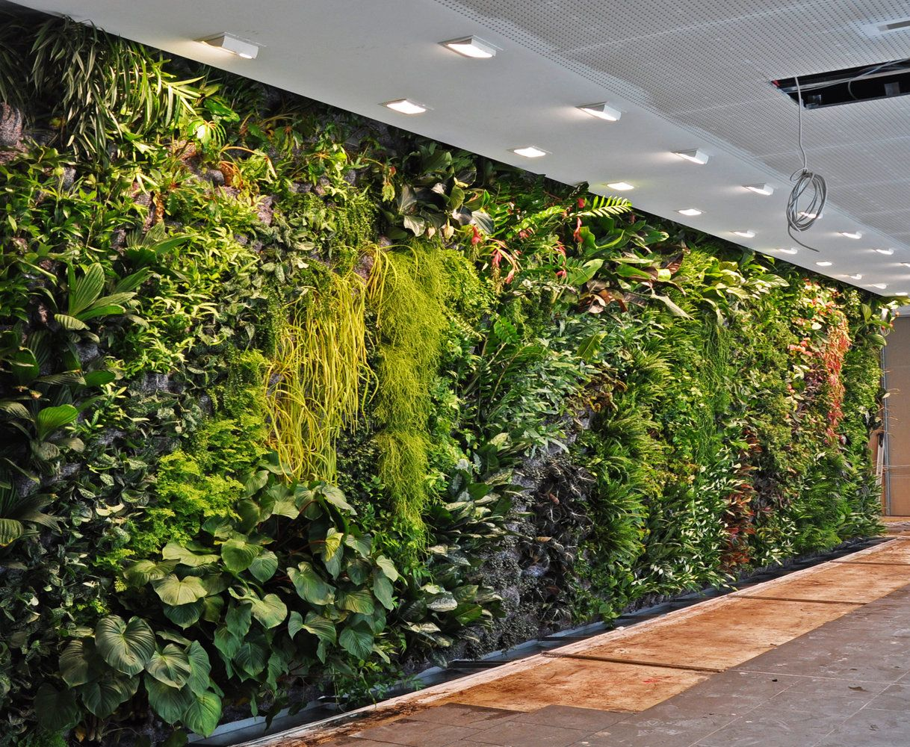

**Our future vision for farms**

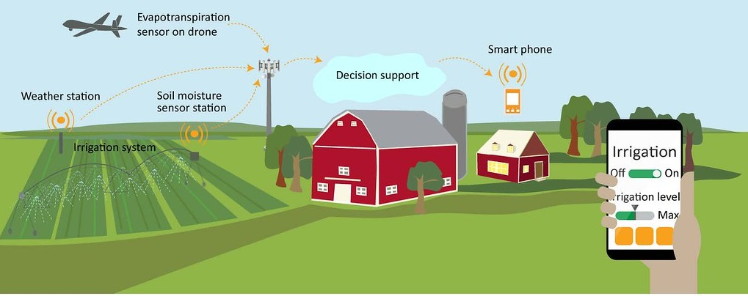

**Disadvantages:**

1. High initial cost to set up system
2. Requires regular maintenance
3. If any expensive sensors are being used, there is the risk of them being stolen

**Presented by:**

Somil Bansal

Rishi Kunnath